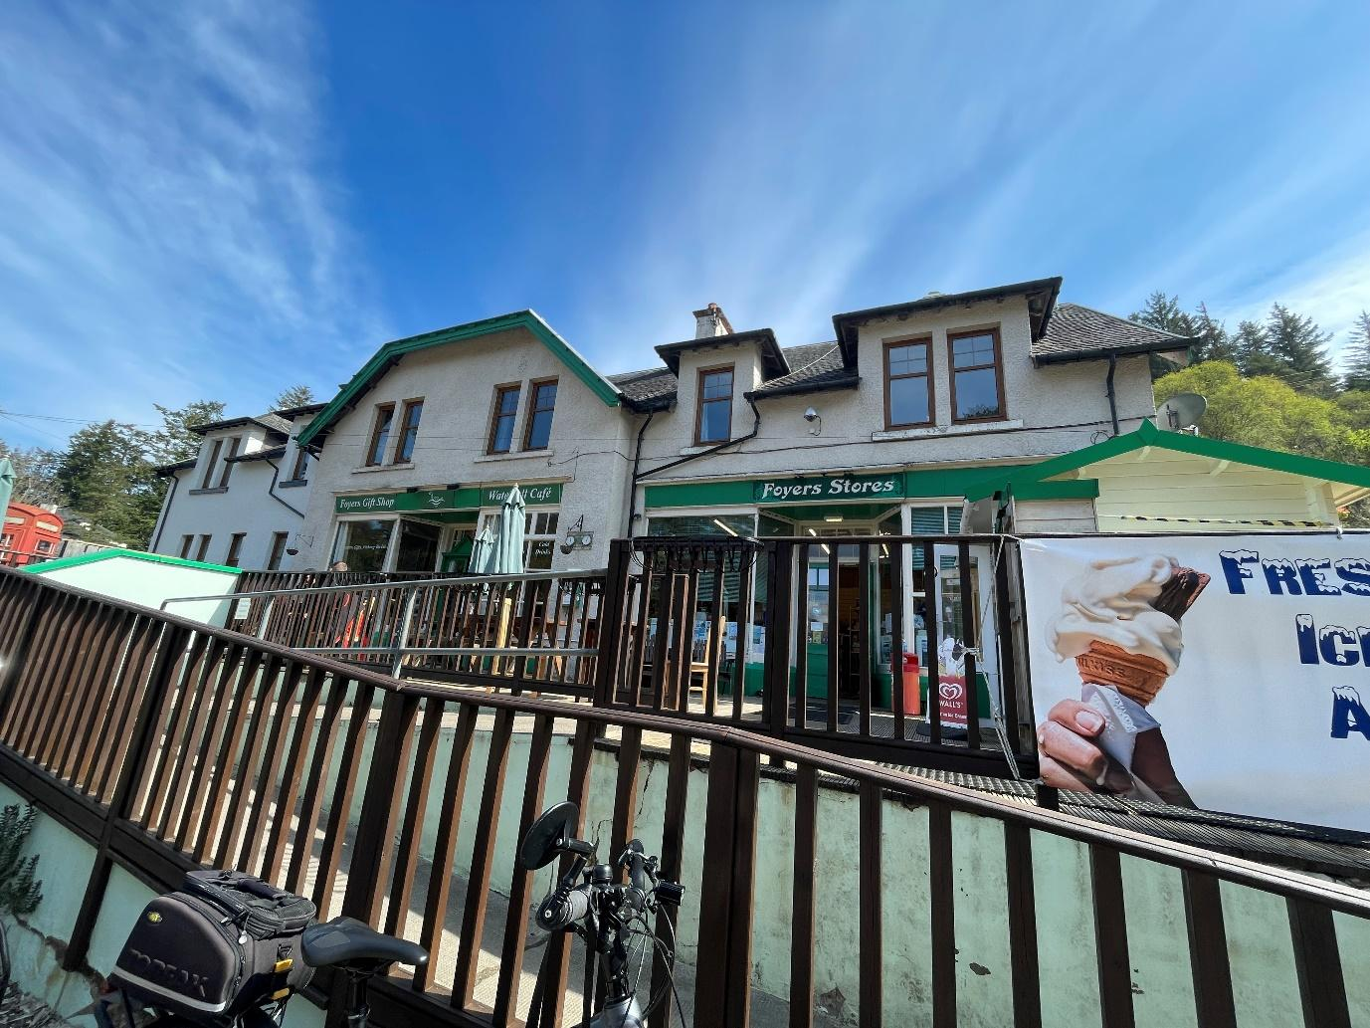
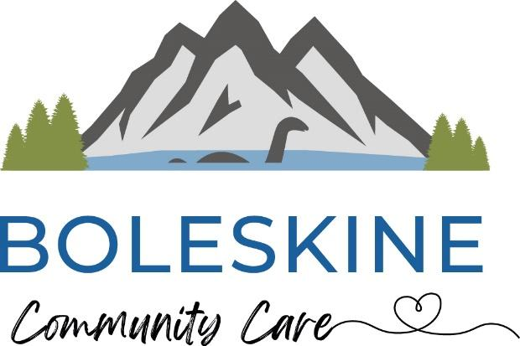
Business Plan Summary V2
Boleskine Community Care
Community Ownership of
Foyers Stores

January 2026

Contents
1. About this Document 3
2. Why Foyers Stores Matters 3
3. Why community ownership is being proposed 4
4. Who is leading the project 4
5. What the community has said 4
6. How the proposed model works 5
7. Governance: The Management Committee 5
8. Professional support and staffing 6
9. Future phase: affordable local housing 7
10. What will stay the same — and what may change 8
11. The Vision 8
12. Community benefits 9
13. Financial position of the business 10
14. Financial Projections 11
15. Funding overview (high level) 11
16. What happens next 12
17. Staying involved 13
18. In summary 13
Mailing list sign-up form 15
Community Share Offer Pledge – Register Your Interest 16

1. About this Document
This summary business plan explains the proposal to bring Foyers Stores, Café and Post Office into community ownership.
It has been written for local residents, to explain:
- why the project is happening
- how it will work
- who will manage it
- what it means for the community
- what will happen next
A full technical business plan has been prepared to support funding applications, due diligence and governance. This will also be published for the community.
A separate community share offer document will be published at a later stage and is not part of this summary.

2. Why Foyers Stores Matters
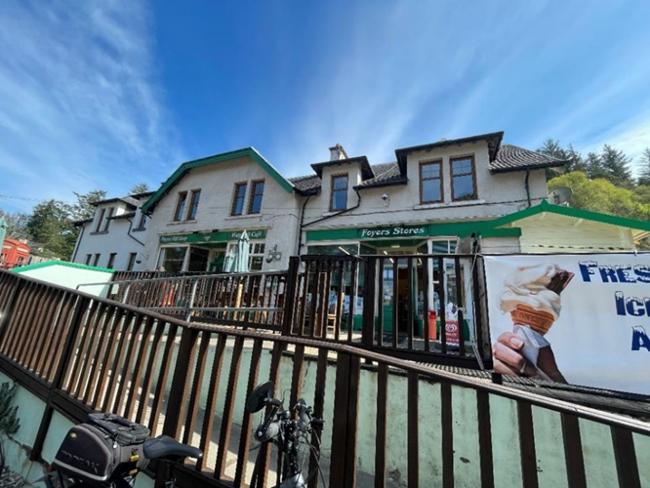
Foyers Stores is far more than a shop. It is:
- the only shop on the south side of Loch Ness between Inverness and Fort Augustus
- a Post Office, café and social meeting place
- a key local employer
- an essential service during winter weather, power cuts and road closures
For many residents, particularly older people, those without cars and people living in more remote parts of the area, the shop and Post Office are a lifeline, providing access to food, services and human contact close to home.
Community engagement has shown overwhelming concern about the consequences of losing the shop, both practically and socially.

3. Why community ownership is being proposed
The current owners of Foyers Stores have taken the decision to sell. While the business is trading, there is a real risk that the shop, café and Post Office could be lost if no locally rooted solution is found.
Community ownership offers a way to:
- protect essential services for the long term
- keep decision-making local
- reinvest income back into the community rather than private profit
Across Scotland, community ownership has proven to be a resilient and sustainable model for safeguarding local shops and services where private ownership is no longer viable or secure.

4. Who is leading the project
Boleskine Community Care (BCC) is leading the project.
BCC is a locally based charity that has worked in Stratherrick and Foyers for over a decade, delivering:
- care and support services
- community transport
- wellbeing activities
- The Community Hub
BCC is widely recognised as a trusted anchor organisation and is identified in local plans as playing a central role in supporting community wellbeing and resilience.
As BCC has strong governance, financial controls and local accountability, it is well placed to take ownership of the building and safeguard it for long-term community benefit. The organisation has seen significant growth in its income and turnover and has a robust financial record

5. What the community has said
Extensive community engagement has taken place, including:
- a community survey
- public meetings and drop-in sessions
- discussions with local organisations, suppliers and businesses
Key messages from the community include:
- very strong support for community ownership of the shop and Post Office
- clear concern about the impact of losing the shop
- interest in more local produce, improved choice and a welcoming café
- support for using the upstairs accommodation for local housing rather than holiday lets
Community feedback has directly shaped the proposals in this plan and will continue to inform decisions as the project progresses.

6. How the proposed model works
The project uses a clear and proven structure that combines secure community ownership with professional management.
Building ownership
- Boleskine Community Care will own the building.
- This ensures the shop, café and Post Office are protected as a long-term community asset.
- BCC will retain strategic oversight of the property.
Operating the store
- Day-to-day operation of the shop, café and Post Office will be carried out by Foyers Community Stores Ltd.
- Foyers Community Stores Ltd is a Community Benefit Society set up using the Plunkett Uk Model Rules.
A Community Benefit Society is:
- a not-for-profit organisation
- owned and controlled by the community
- set up to benefit the wider community rather than private individuals
- legally required to reinvest any surplus back into the business or community
This structure allows the shop to be community-owned but professionally run, with clear accountability and local control.

7. Governance: The Management Committee
Foyers Community Stores Ltd is governed by a Management Committee, sometimes referred to as a board.
Who will sit on the Management Committee
- The committee will be made up primarily of local people.
- Members will be selected to ensure a strong mix of relevant skills and experience, including:
  - business and financial management
  - retail, hospitality or customer service
  - governance and strategic oversight
  - community knowledge and local understanding
A number of local residents have already expressed interest in joining the Management Committee. A formal selection process will be used to ensure the committee has the right balance of experience and capacity to run the business responsibly.
How decisions are made
- The Management Committee will set strategy and provide oversight.
- Day-to-day operations will be delegated to paid staff.
- The committee will meet regularly to review finances, performance and community feedback.
This ensures strong local accountability, without relying on volunteers to run the business day to day.

8. Professional support and staffing
To ensure a smooth and well-supported transition into community ownership, the project includes dedicated professional support and paid management roles. This business will not rely on volunteers in any way.
Retail consultant (first 3 months)
For the first three months following transfer, a specialist retail consultant will be appointed.
The consultant will:
- review systems, suppliers and pricing
- advise on layout, stock mix and customer flow
- help put robust policies and procedures in place
This short-term role reduces risk and helps ensure the community business starts on a solid footing.
Development Manager (SFCT Funded)
A Development Manager will be appointed to lead the transition phase and early development of the business.
This role will:
- oversee the move into community ownership
- implement recommendations from the feasibility and business planning work
- support staff and the Management Committee
- help embed strong systems, reporting and performance monitoring
Store Manager (Current Role)
A Store Manager will be responsible for the day-to-day running of the shop, café and Post Office.
Responsibilities will include:
- managing staff and rotas
- stock control and supplier relationships
- customer service and community feedback
- ensuring compliance with retail, food and Post Office requirements
The Store Manager will be supported by existing staff and seasonal workers, all paid fairly and trained appropriately.

9. Future phase: affordable local housing
Once the building has been successfully acquired and the shop, café and Post Office are operating securely under community ownership, the next stage of the project will focus on the upstairs accommodation.
Community feedback, local plans and workforce experience all highlight a shortage of affordable housing in Stratherrick and Foyers. This lack of housing makes it difficult to recruit and retain staff for essential services and local businesses.
The upper floor of the building provides an opportunity, in a later phase, to:
- renovate the existing accommodation
- bring it up to modern standards
- provide 3 affordable flats for local people
This work will:
- be progressed after the shop transfer is complete
- be subject to separate funding and professional advice
- be delivered in line with housing regulations and best practice
Boleskine Community Care will lead this element of the project, drawing on specialist housing advice to ensure the accommodation is well managed, compliant and genuinely beneficial to the community.
Importantly, this future phase does not delay or complicate the purchase of the shop. It represents a longer-term opportunity to maximise community benefit once the building is securely in local ownership.

10. What will stay the same — and what may change
What will stay the same
- The shop, café and Post Office will continue to operate.
- Local employment will be protected wherever possible.
- The shop will remain a place for everyday essentials and social connection.
What will change over time
- Stock range may evolve to better meet local needs.
- More local produce and crafts may be introduced.
- The café offer may be refreshed.
- Small improvements may be made to the building.
Any changes will be phased, carefully managed and informed by community feedback.
A professional conditions survey was carried out on the building; this highlighted £30,000 worth of essential repairs. This includes new windows on the ground floor, new flooring cover throughout the shop and Café and repairs to the roof. These repairs have been fully funded by The Scottish Land Fund.

11. The Vision
The potential for Foyers Community Stores is endless; some ideas have been listed below-
- Breakfasts (Tap into passing trade in mornings)
- Events
- Takeaway evenings
- Cheese & Wine Nights
- Taco Tuesdays
- Delivery Service (Scoot)
- InPost Lockers
- Acquire alcohol license for Café
- Takeaway coffee machine
- Mr Whippy Machine
- Electric car chargers
- Hot waffles/Hot drinks in outdoor shed during winter
- Produce from local estates
- Hill to Larder workshops
- Fishing Permits
- Picnic Packs
- Pre-made sandwiches/lunches

12. Community benefits
The project will deliver long-term benefits across the community.
Social
- Reduced isolation
- Continued access to essential services
- A welcoming place to meet and connect
Economic
- Protection of local jobs
- Support for local suppliers
- Money spent locally staying local
Environmental
- Reduced travel for basic shopping
- Increased local sourcing
- Potential future energy efficiency improvements

13. Financial position of the business
Foyers Stores is an established, trading business that has been operating for many years and has continued to do so profitably.
The shop, café and Post Office generate income from a mix of:
- grocery and retail sales
- café trade
- Post Office services
Recent trading shows that the business is capable of covering its day-to-day costs and supporting local employment. Like many small rural businesses, profit margins are modest, but the core operation is viable and resilient. With small improvements and vision these margins will increase.
The reason community ownership is being pursued is not because the business is failing, but because:
- the current owners wish to sell
- limited reinvestment has taken place in recent years
- without community action, there is a risk the services could be lost
Community ownership creates the opportunity to:
- protect a business that already works
- reinvest surplus back into the shop rather than extracting profit
- make careful improvements over time, guided by community needs
The aim is to build on an existing, functioning business and place it on a secure footing for the long term, rather than fundamentally change how it operates.

14. Financial Projections
Income | Year 1 | Year 2 | Year 3 | Year 4 | Year 5 | Total
Trading & Shares | £442,000 | £462,200 | £464,310 | £464,575 | £464,575 | £2,297,661
Grants | £35,000 | £10,000 | £0 | £0 | £0 | £45,000
Total | £477,000 | £472,200 | £464,310 | £464,575 | £464,575 | £2,342,661
Expenditure | £475,021 | £453,167 | £447,493 | £451,979 | £456,422 | £2,284,081
Surplus | £1,979 | £19,033 | £16,817 | £12,596 | £8,153 | £58,579

In Year One, the financial projections assume that turnover remains broadly in line with the current year. This reflects the intention for the Community Benefit Society (CBS) to take on management of the shop as it is, without making major operational changes during the initial transition period.
The cashflow shows the need for two distinct sources of start-up funding. Community share capital is required to provide working capital, ensuring the business has sufficient cash to operate day to day, manage stock, and cover routine running costs during the initial period of community ownership. In addition, a small grant is sought specifically to fund a Store Development Manager role. This role is critical to supporting the transition, embedding good systems and governance, and laying the groundwork for future growth.
The financial projections are therefore based on modest and realistic growth, rather than any immediate or transformational change to the business. From Year Two onwards, the aspiration is for the management team and board to take a more strategic look at evolving the business. This includes increasing sales, customer numbers and profit margins through a refreshed offer, such as new products, an updated café menu, and community-focused initiatives. Opportunities may include local deliveries, InPost Lockers, and other initiatives designed to increase demand while meeting local needs.
Small, incremental improvements in profit margins are anticipated as smarter management practices and new supplier relationships are introduced. This represents a cautious and sustainable growth approach, focused on long-term resilience rather than short-term risk.

15. Funding overview (high level)
The purchase of Foyers Stores is being supported by major external funding, including a £365,611 award from the Scottish Land Fund. We are awaiting a decision from Stratherrick and Foyers Community Trust on an application to make up the remaining 36% of the funding package. This support will enable the community to acquire an existing, trading, profitable business and secure it for long-term community benefit.
Additional funding from local and community sources will be used to:
- support the transition into community ownership
- ensure adequate working capital
- enable fair pay and appropriate staffing levels
- allow for careful, phased improvements to the business
The financial approach is deliberately cautious and realistic. The aim is not to maximise profit, but to ensure the shop, café and Post Office are:
- well managed
- financially stable
- able to reinvest modest surpluses back into the business and community
Detailed financial projections, assumptions and risk management arrangements are set out in the full business plan and have been independently reviewed as part of the funding process.

16. What happens next
The project will move forward in clear, manageable stages.
The next steps include:
- confirmation of final funding
- completion of legal processes to transfer ownership of the building
- appointment of professional support and management roles
- preparation for operating the shop under community ownership
Once the shop, café and Post Office are operating securely, work will begin on planning the future phase of the project to renovate the upstairs accommodation for affordable local housing, subject to separate funding and approvals.
Throughout this process, the community will be kept informed through:
- public meetings
- newsletters and local communications
- online updates
A separate community share offer will be published at a later stage, setting out how people can choose to invest in the project if they wish. That document will include full details on shares, risks and governance and is not part of this summary.

17. Staying involved
Community ownership depends on openness and participation.
Local people will be able to stay involved by:
- receiving regular updates
- attending public meetings and events
- becoming members of Foyers Community Stores Ltd
- supporting the shop once it is operating under community ownership
There is no requirement for everyone to be involved in the same way, simply continuing to use and support the shop will be one of the most important ways the community can help ensure its success.
If you would like to receive regular updates, please use the form on the final page of this document to sign up to the mailing list.

18. In summary
This project is about protecting something the community already values and ensuring it remains available for future generations.
By bringing Foyers Stores, Café and Post Office into community ownership, the community will:
- secure an existing, viable local business
- retain essential services in a remote rural area
- create opportunities for reinvestment and improvement
- strengthen local resilience and self-reliance
The proposal builds carefully on what already works, combines community control with professional management, and takes a long-term view of what Stratherrick and Foyers needs to thrive.

Mailing list sign-up form
Name:

Email address:

Postcode (optional):

☐ I would like to receive updates about the Foyers Stores community ownership project.
Preferred format (optional):
☐ Email updates
☐ Printed updates (where available)
How to return this form
- In person: return to Foyers Stores or the BCC Hub
Email: send details to olivia@foyerscommunitystores.co

Community Share Offer Pledge – Register Your Interest
Thank you for your interest in community ownership of Foyers Stores.
By completing this form, you are helping us plan a community share offer that keeps the shop, café and Post Office in local hands.
Registering your interest:
- does not commit you to investing
- helps us understand the level of support
- ensures you receive full information when the share offer opens
Please follow the link below to complete the form online- https://forms.office.com/e/JPPMgAtNqG?origin=lprLink
Your details
Full name ____________________________________
Email address_________________________________
Phone number_________________________________
Postcode______________
Community shares & membership
Foyers Community Stores Ltd is a Community Benefit Society.
Anyone who buys at least 25 £1 shares becomes a member of the Society, with one vote, regardless of how many shares they hold.
Please tick any options that apply:
☐ I would like to receive updates about the Foyers Community Stores community share offer
☐ I am interested in becoming a member by purchasing the minimum shareholding of 25
☐ I am considering investing in community shares
Indicative investment amount
(This is only to help with planning and does not commit you)
☐ £25
☐ £50
☐ £100
☐ £250
☐ £500
☐ £1,000
☐ Other amount (please specify): £ ______________________
Larger or confidential investments
☐ I may be interested in making a larger investment and would like to discuss this confidentially with a project team member
Staying in touch
☐ I am happy to be contacted by email about the Foyers Community Stores share offer and related updates
☐ I understand that my details will be stored securely and used only for purposes related to the community share offer, in line with data protection regulations
Signature (paper forms only)
Date
How to submit this form
Return a paper copy to: The Hub or Foyers Stores
Or email a completed form to:
Olivia@foyerscommunitystores.com

