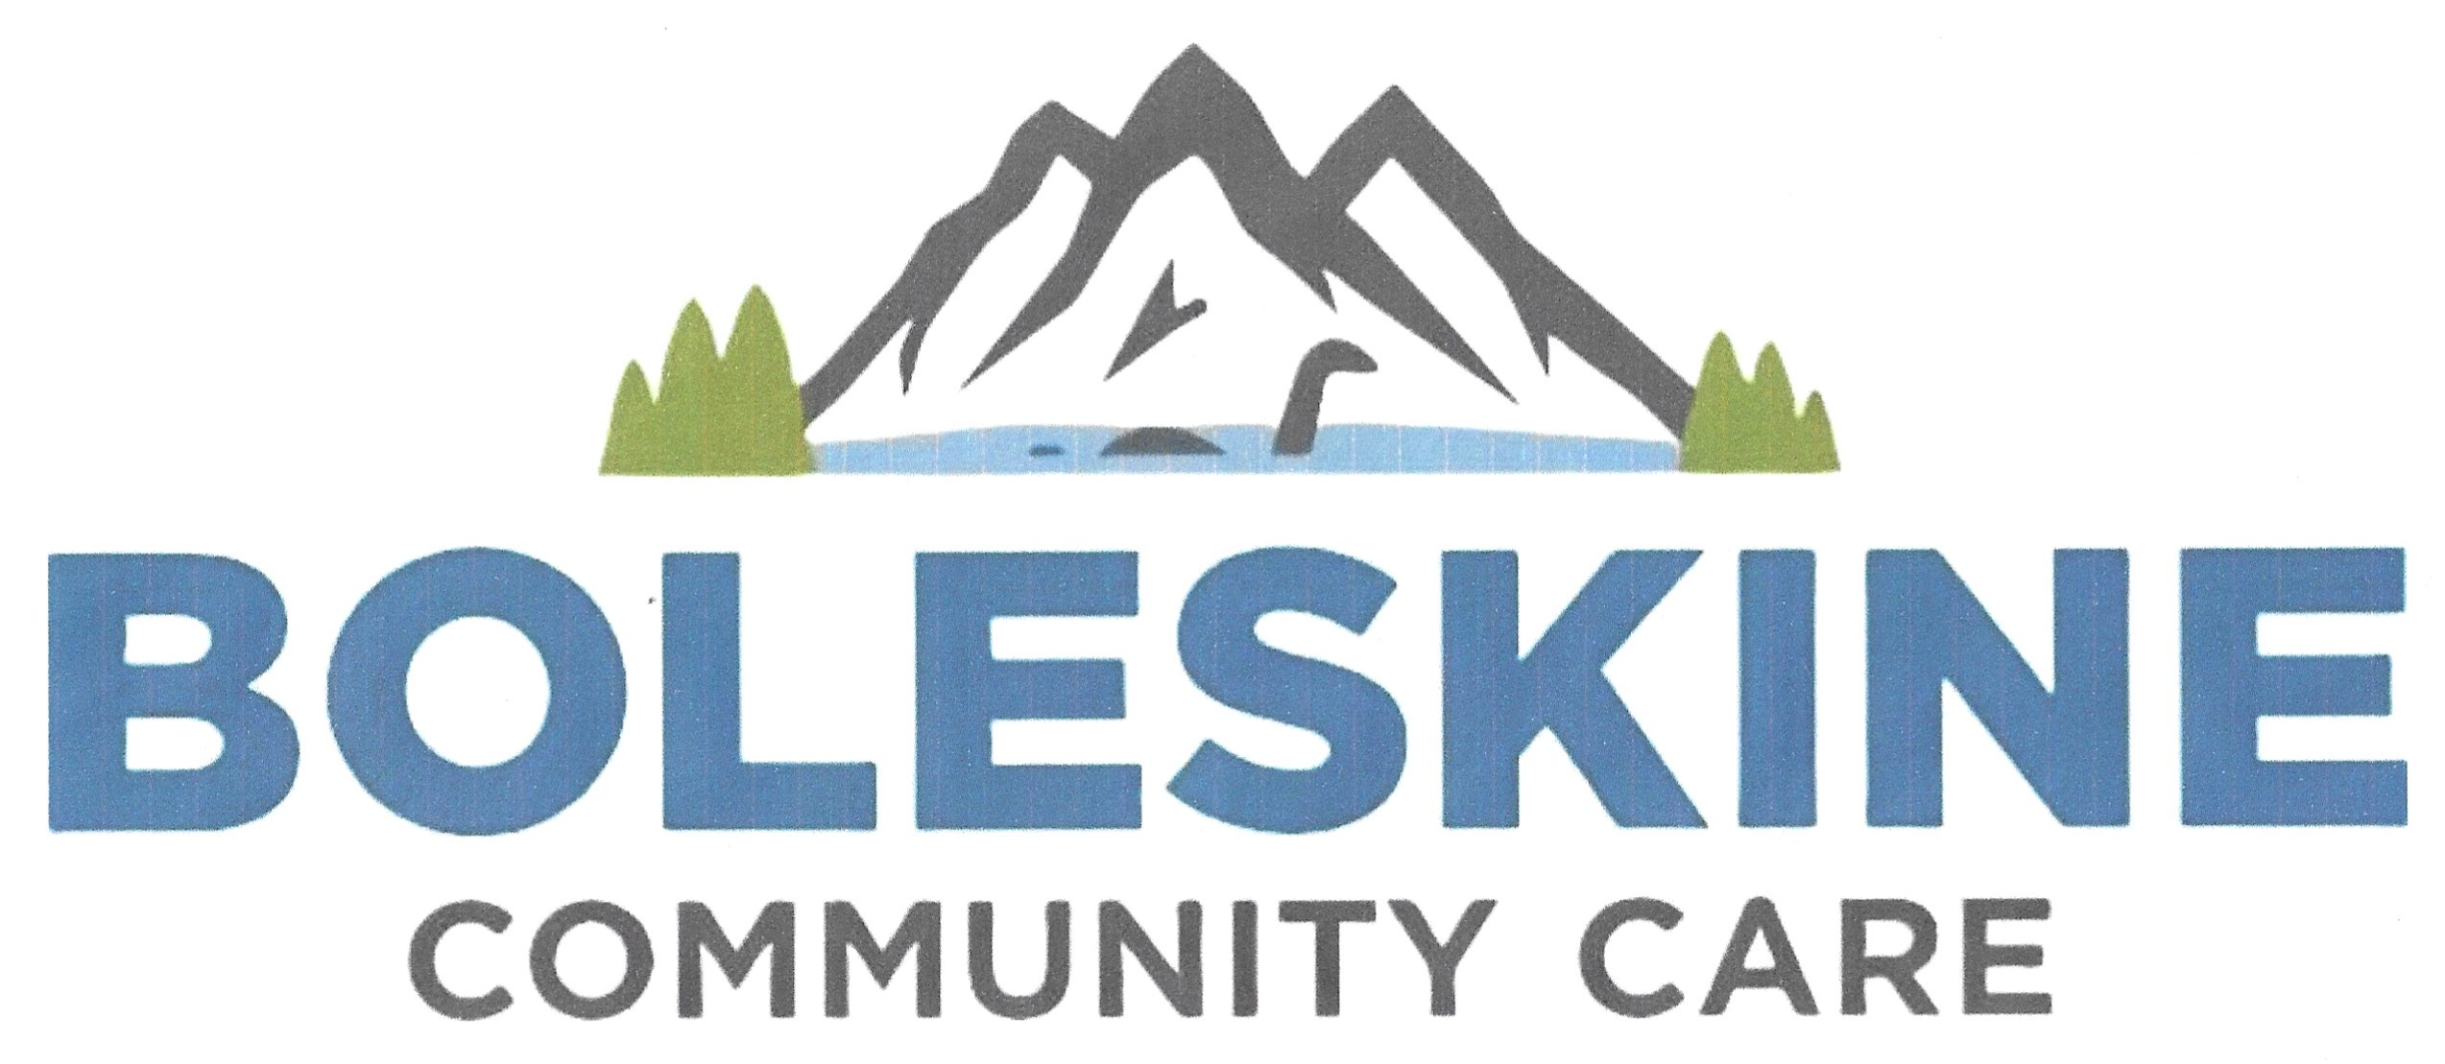

**Environmental Protection and Improvement**

Boleskine Community Care (BCC) believes that eriodicallytor and report annuafterciationand Fisheries with a common Chair, Director and environmental protection and improvement contribute to the well-being of communities. Our core objectives are: -

• To improve the quality of life, health, well-being and independence and to reduce social isolation of people of all ages in need due to age, ill health, disability or social circumstances

• To provide recreational facilities and / or organise recreational activities with the object of improving the conditions of life for the persons for whom these facilities or activities are primarily intended.

Whilst seeking to conserve and enhance the environment of Stratherrick & Foyers in our initiatives and projects BCC recognises that our own activities in so doing have the potential to have environmental impacts which we must seek to reduce and minimise.

To do this we will:

1. Recycle our office waste materials.

2. Where possible, encourage the use of electric or hybrid vehicles, public transport, cycling and car sharing by staff and Board members to minimise our carbon footprint and travel costs.

3. Make use of audio conference and video conference where appropriate to reduce unnecessary business travel and associated environmental impacts.

4. Support flexible and home working arrangements for staff to reduce travel and associated environmental impacts where this can be done whilst maintaining effectiveness;

5. Have our staff work from shared office premises so that the environmental impacts of heating, lighting and other activities required to support an office base are themselves shared;

6. Identify new and additional ways in which we can improve our environmental performance and reduce our environmental impacts.

When we commission and contract work with external suppliers for major project programmes, we require contractors to confirm that they will comply with all relevant environmental legislation when proposing and implementing works. In addition, we include "sustainability" as one of the key specifications on which tenders are invited and assessed by BCC to support the appointment of contractors who deliver work whilst actively considering the environmental sustainability of their practices.

The Community Liaison and Development Officer or responsible Trustee will monitor and report periodically to the Board of Trustees on the implementation of this policy to ensure that it is being effectively included in all inductions, implemented and considered in our operations by our staff and volunteers.