Retail Consultant – Community-Owned Business

Job Advert

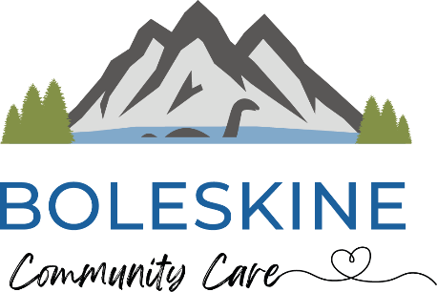
Location: Foyers Stores, near Inverness (hybrid: on-site and remote)
Contract: Fixed-term consultancy (3 months)
Period: March – May 2026
Time commitment: Approx. 15 days per month
Fee: Up to £10,000 (inclusive of VAT and expenses)
Funding: This role is funded by the Scottish Land Fund

About the opportunity
Boleskine Community Care is leading the community acquisition of Foyers Stores, a vital rural shop, café and Post Office serving the Stratherrick and Foyers area on the south side of Loch Ness.
As part of the transition to community ownership, we are seeking an experienced Retail Consultant to provide hands-on, practical support during the early months of operation. While the community group has strong governance and community delivery experience, specialist retail expertise is essential to ensure the shop launches smoothly and operates sustainably from the outset.
This is a collaborative, supportive role focused on building confidence, embedding good systems and supporting local people to succeed.

About Foyers Stores
Foyers Stores includes:
- A licensed grocery shop
- A café
- A Post Office
- A small ice cream counter
It is the only shop serving a 35-mile stretch between Inverness and Fort Augustus and plays a critical role for local residents as well as visitors to the Falls of Foyers.

What the role involves
The consultant will work closely with:
- The Development Manager
- Shop staff
- Directors of Foyers Community Stores Ltd
- Boleskine Community Care
Key areas of support include retail operations, staffing, systems, supplier relationships and early-stage marketing.

Who we’re looking for
Essential
- Proven experience in retail consultancy or senior retail management
- Strong understanding of small-scale or rural retail operations
- Experience working with EPOS systems, pricing and stock control
- Ability to work collaboratively with non-specialist stakeholders
- A practical, supportive and solutions-focused approach
Desirable
- Experience of community-owned, cooperative or social enterprise businesses
- Experience of multi-service retail (e.g. shop + café + Post Office)
- Familiarity with rural or remote communities

How to apply
Please submit:
- A short covering email outlining your relevant experience and approach
- A CV
- Two references from previous consultancy or retail support work
- Your availability during March–May 2026
Send applications and enquiries to:
csc@boleskinecc.com
Closing date: 06/02/26
Early expressions of interest are welcomed.

